Data Provision

*Data provision* is a detailed and complete framework in which is possible to specify data and metadata provided by a data provider. The importance of the SDMX data provisioning specifications is in the possibility to discover data and metadata shared by all data providers in the SDMX community.

For this scope, *Data Provision* specification is organized in three main blocks: *Provisional Agreement*, *Registration* and *Subscription*.

The *Provisional agreement* is the core of *Data Provisioning*. It links a data provider to the data or metadata flows shared as it possible to see from the picture below.

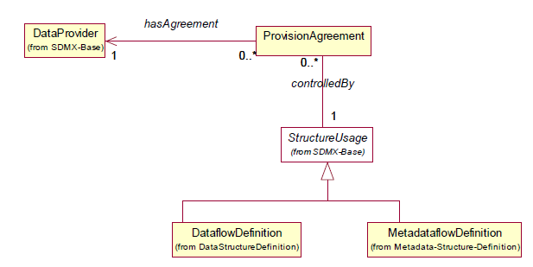

***Figure 1. Provision agreement class***

One example of provisional agreement is the National Accounts data (dataflows) provided by the ESS member states (data providers). Through the agreement, all the ESS member states agreed to provide periodically dataflows related to the ESA-2020 DSDs.

The *Registration* block include all the information related to the registration of the provisional agreements into a common registry. In the specification of this block are also the modalities on which is possible to retrieve data, for example using a web service (pull method) or static source (pull and push method).

The block related to the *Subscription* is a feature for people that wants to access data because it allows through a subscription a managed access to the agreements and by consequence to data. This facilitate also the implementation in providing notifications of new deliveries in the registry.

The discovering of data is possible thanks to the link of data and metadata flows to the structural metadata (DSDs and MSDs) associated. The picture below shows a user searching through a category scheme, the dataflows and metadataflow of its interest, discover data providers having agreement on those flows and finally query directly the sources to retrieve information.

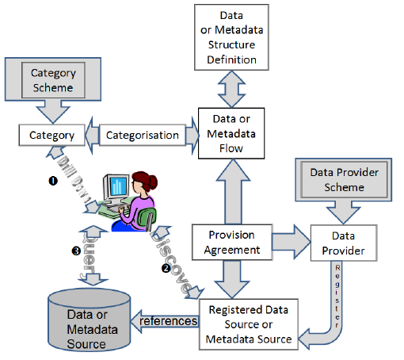

***Figure 2. Data and Metadata discovering***

The Global Registry is an example of storage of provisional agreement by some international organizations that allows by the provisional agreements themselves to access to data.

The Figure 3 is a view on some provisional agreements stored in the SDMX Global Registry.

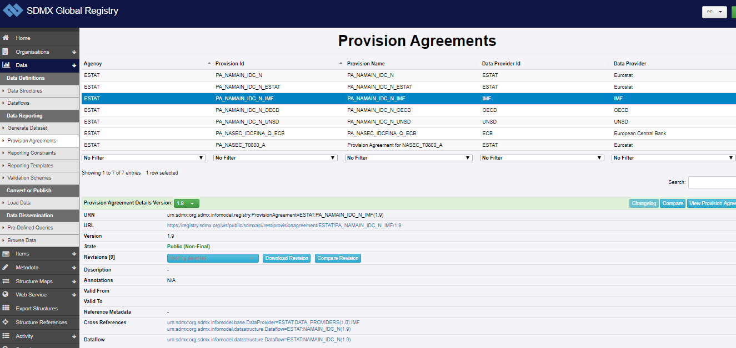

***Figure 3. Provision agreements in the SDMX Global Registry***

An agreement can exists without having a registry but go further on this approach can be a real benefit with a view of sharing and of simplifying the access to data.

A provisional agreement as well several SDMX artefact can have constraints.

Constraints are useful in this case to list the valid content of data or metadata if data provider cannot, for any reasons (unavailability or inapplicability) provides all data or metadata foreseen by the dataflow or metadataflow structure. They can also be used in some cases to validate data.

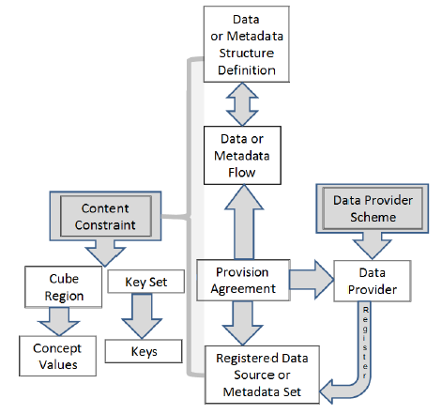

***Figure 3. Constraints in Data Provisioning***

The applicability of constraints to Provisional Agreement follows a precedence rule from the higher to the slower level among the artefacts listed below:

* Data Structure Definition and Metadata Structure Definition (higher level)
* Dataflows and Metadataflows
* Provisional Agreement (lower level)

This means that a constraint applied on a level has affected the lower levels so that, the Provisional Agreement inherits all the constraints defined in the higher levels and it can have added constraints.

For example, a DSD can be restricted in some components because some specific aggregates are never used in a domain. In a specific dataflow of the DSD, within the EU can be constrained in the REF_AREA concept to assume only the EU countries values, while, for a provision agreement related to a data provided from a specific country, the constraint might limit to a single code. For a detailed description of Constraint please refers to the SDMX standard and to the Technical Notes[1].

A Data Provider too, can have a constraints but this is only related to the Calendar Release that is on the period of data dissemination. Constraints cannot be applied to Data Provider because it can be associated (usually is that) to more than one DSD or MSD so a single constrain on a codelist can have impact on more DSDs and this is not possible.

1. http://sdmx.org/wp-content/uploads/SDMX_2-1-1-SECTION_6_TechnicalNotes-march-2013.pdf